ThomX Storage Ring elongation
I. Chaikovska, V. Kubytskyi, V. Mytrochenko (ThomX collaboration)

Retour d'expérience

Intervention for the ring elongation was done accurately and professionally, it was finished earlier that was previewed. Intervention took one week (Week #7, March, 12-16) and after that one week of vacuum pumping was necessary for the half of the ring (Week #8, March, 19-23). Overall result is positive, good placement of spacers, good alignment of the moved elements with no vacuum leaks.

Teams involved: mechanics workshop, mechanics and alignment group, vacuum, and beam physics group.

Preparation and realisation of intervention, preparation of mechanical drawings of spacers, fabrication, installation and alignment work were coordinated by Rodolphe Marie.

Coordination and assignment of the resources could be improved. Request of resources to help Rodolphe was made well in advance, but the assignment and communication back was not conclusive. This coincided with period of the holidays, and search for two persons was made in very last moment. This did not influenced quality of the work.

Ring Beam Recommissioning

Week #9 February, 26 - March, 1

Goal: Restart of the beam, application of the new ring optics, recommissioning of the ring and search for the new RF frequency.

Restart of the machine after the mechanical intervention was performed on Monday. Tuning of the injector and injection in the Ring.
After the beam studies with the new optics focused on the search of the new RF frequency, the beam storage was first obtained at 500.1 MHz. The orbit was highly dispersive. Further studies converged to the RF frequency of 500.067 MHz.
On Thursday due to the micro-cut of the electricity several subsystems were restarted and needed the support intervention (RF gun laser and synchronisation system).
The injector operation condition changed, the RF power attenuator reading were changed from 1.36 to 2.1. To be addressed by the RF experts.
After beam start-up and beam tuning (following the electricity cut), good storage was obtained on the frequency of 500.067 MHz and new lattice (see Figure 1). The storage efficiency is similar to what we had before intervention and fully acceptable for the X-ray generation (see Figure 2). The very first dispersion function of the ring was measured by changing the injected energy (see Figure 3). Work in progress.
Attempt to perform the BBA. Very confusing results, probably due to the injection stability. Work in progress.

Week #10 March, 4 - March, 8

Goal: Beam studies in the ring and X-ray generation.

On Monday morning, the problem with the vacuum ion pump was discovered in the ring RF cavity. The visual inspection showed the water leakage of its cooling system (water on the floor). The vacuum group changed the cables and the RF cavity cooling system was repaired on Tuesday.
The beam could be restarted on Wednesday. Problems to restart the ring RF cavity. After intervention, it was restarted in the early afternoon.
Beam studies were started in the ring aiming to confirm the nominal RF frequency.
At the same time, the problem with the synchronisation on the new RF frequency (for the Fabry-Perot cavity) was discovered. Several attempts to address this issue by Vincent Chaumat, Ronic Chiche and Kevin Dupraz. It seems that a solution was found on Thursday (to be checked).
Overall on Thursday, the beam behaviour was very unstable. The beam energy was fluctuating making impossible the ring beam studies.
Attempts to do the BBA with one turn in the Ring. Due to the unstable injector energy, no results are obtained. This approach is not suitable in our conditions.
On Thursday, the problem with the vacuum ion pump appeared again. After inspection by Mohamed El Khaldi and vacuum group, it was found that the feedthrough underwent a big discharges making impossible it further usage. The exchange of the feedthrough will break the vacuum and so, no more beam operation was possible during that week.

Conclusions
The mechanical intervention on the elongation of the ring was done. The new RF frequency 500.067 MHz corresponds to the simulation and modelling. It is coherent with our physics studies performed for this intervention.
A good suitable storage was achieved for X-ray generation. The ring was ready for the operation with the Fabry-Perot cavity.
The stability of the beam coming from the linac is unpredictable and should be further studied and improved to continue the detailed beam physics studies in the ring.

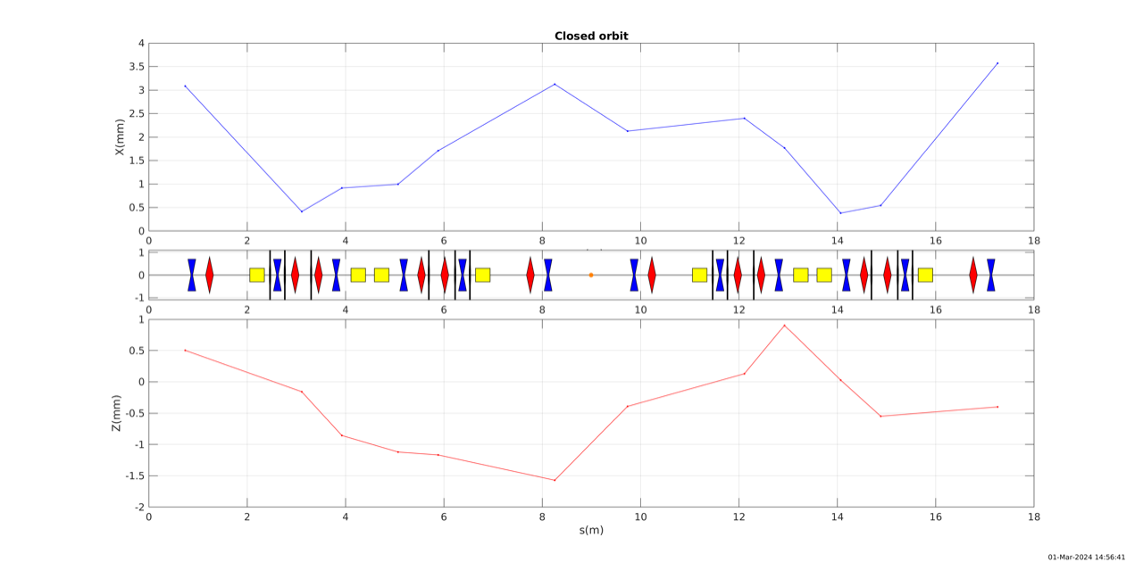
Figure 1: The first corrected closed orbit.

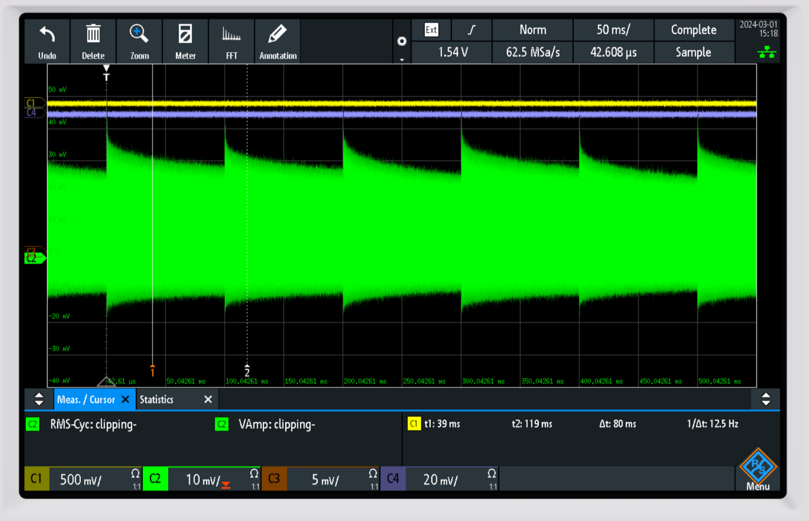

Figure 2: Example of beam storage during 100 ms (10 Hz)

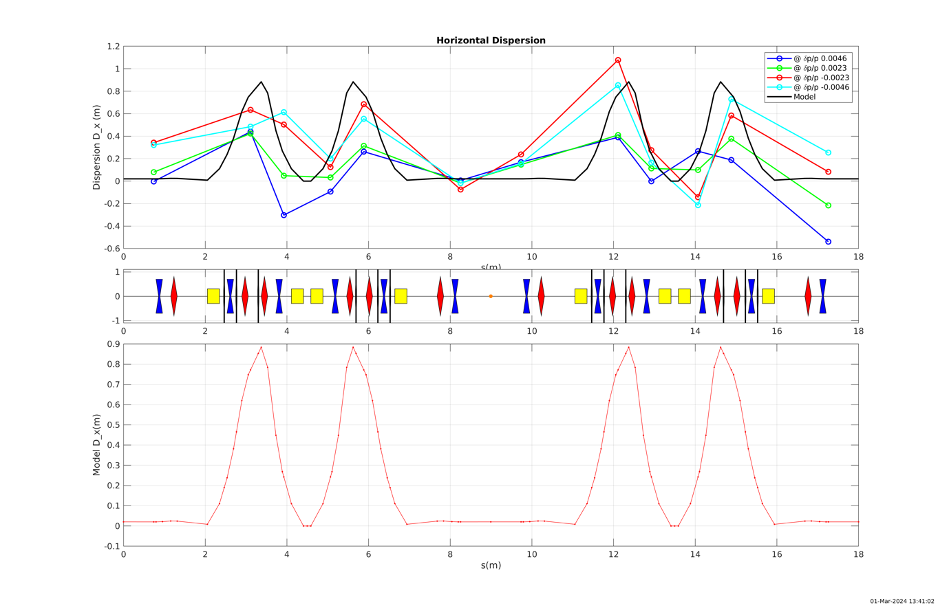
Figure 3: First dispersion measurements by changing the injected energy (RF cavity is OFF)

