



**Milestone number 31: Internal communication plan**

Related WP(s): WP9, Task 9.1

Due date: project month 6

Means of verification: plan

**Context**

“The Steering Committee will propose an **internal communication plan** to the Governing Board to streamline the communications between the WPs and management. The effectiveness of the internal communications within the organisation will be monitored by the Governing Board. The Coordination Panel informed by the Steering Committee and assisted by the project management will prepare the annual meetings, the mid-term reviews and deliver an internal iSAS newsletter every 6 months.”GA p77

**iSAS Roles and Responsibilities**

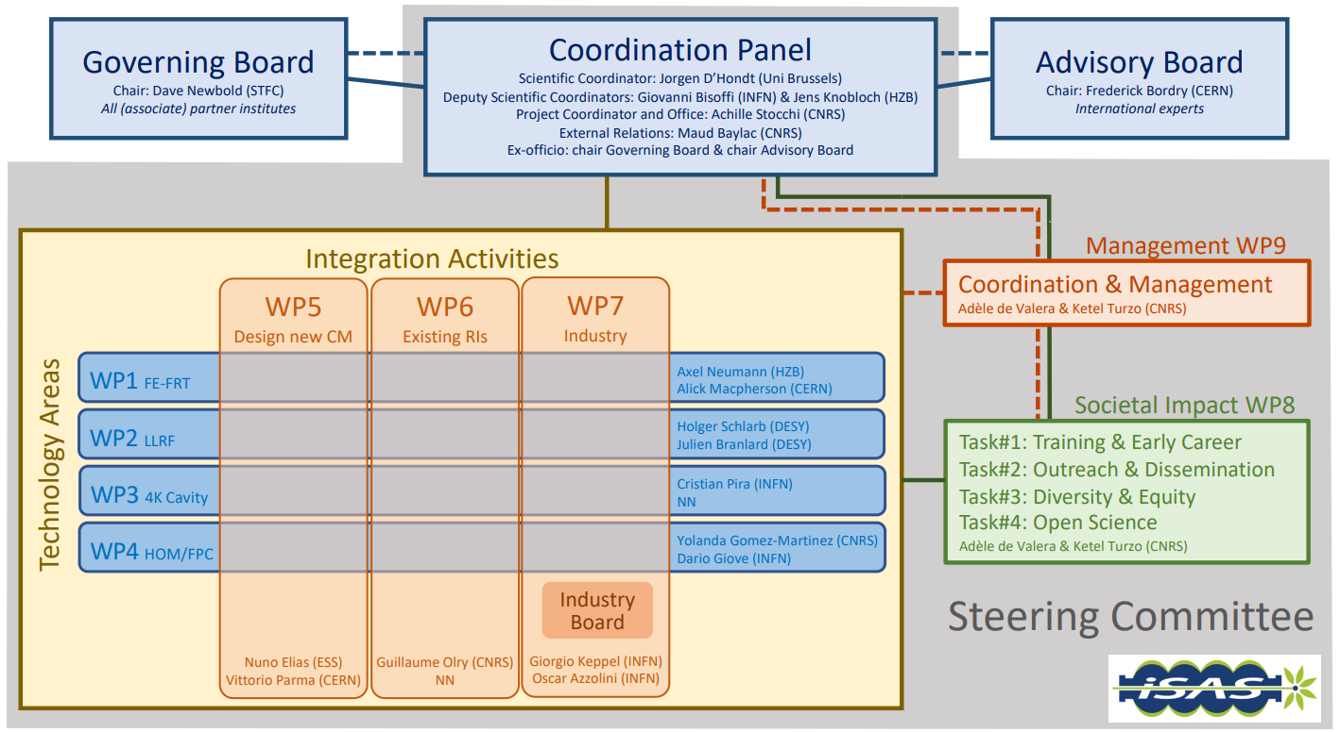

To ensure an effective management of the iSAS project, three levels will be defined:

* An operational level with WP leaders & deputies
* A management level with the Cross-coordination between WPs in the Steering committee, and the Coordination panel supported by the European project manager
* The ultimate decision-making level of the project, performed by the Governing Board with the support of the Advisory Board

**Internal Communication Objectives**

The internal communication plan was developed to achieve the following objectives:

* To ensure that all the project members are aware of the project ongoing activities, and which outcomes it will deliver.
* To develop a desire amongst all members involved in the project to contribute towards the successful implementation of the project and the delivery of the benefits.
* To manage expectations among project members. The Scientific coordinator and the Project coordinator aim to build a reputation as a trusted quality and innovative information source.
* To provide timely and accurate information to all project members about the steps to be taken. This will support the project implementation, thereby meeting the project objectives. Key message: For each project member – what to do, when to do it, and how much time it should take.

**Internal Communication methods**

The internal communication plan includes the establishment of a contact database and defines which communication channels are used to what purpose. The communication plan with all selected communication methods is described as follows:

|  |  |  |  |
| --- | --- | --- | --- |
| **COMMUNICATION CHANNELS** | **OCCURRENCES** | **PURPOSE** | **FREQUENCY** |
| E-mail communication | Communication between all WP, committees & management | To organise meetings  To inform  To remind (of due dates for example) | As much as needed |
|  | iSAS newsletter | To inform | Every 6 months |
| Video conference communication | Weekly meetings between Scientific coordinator, Project coordinator & European project manager | To manage the project on a current issues basis | Weekly |
|  | Thematic meetings (like website meetings) | To cooperate | Upon request |
|  | Work package meetings | To cooperate | Monthly |
|  | Steering committee meetings | To monitor the progress of work packages | Every 3 months |
|  | Coordination panel meetings | To manage the scientific coordination of the project | Monthly |
|  | Governing Board meetings | To make formal decisions for the project | Yearly |
|  | Advisory Board meetings | To get scientific & technical advice | tbd |
|  | Industry Board meetings | To create opportunities for valorisation | tbd |
| Documentation repository | Meeting notes | To synchronise information  To document progress | After each key meeting |
|  | WP feedback | To synchronise information  To document progress | Every three months |
|  | Milestones | To synchronise information  To document progress | By each due date (at least a week before for checking) |
|  | Deliverables | To synchronise information  To document progress | By each due date (at least a week before for checking) |
| In-person meetings | Project meetings | To strengthen the project dynamic | Yearly |
|  | Governing Board meetings | To make decisions for the project | Yearly (during project meetings) |
| EU Funding & Tenders Portal | Between European project manager & European commission via the Project Officer | To report on progress  To inform of variations | By due dates & as much as needed (continuous reporting) |