# iSAS Project Data Storage

STFC will provide the project with a SharePoint site for which to store project data and documentation; the site itself will be created on STFC’s SharePoint tenancy.

Each work package will have its own document library (i.e., file storage area). Users associated with a particular work package will have create/edit/delete permissions to said work package library, and only view permissions to other work package libraries. Global permissions can be provided to the co-ordination panel, giving edit rights in all areas.

Permission groups will be created and managed by STFC. During the setup of the site, a list of user’s names, emails, and their associated work package must be provided to facilitate this process. Any additional requests for user group updates should be made via STFC.

Though folders can be used to subdivide libraries into a file hierarchy, it is STFC’s preference to maintain a managed flat structure using metadata tagging. Standard fields used by projects in STFC are:

* **Category**, examples of which include:
  + cost book
  + conceptual design
  + management information
  + meetings
  + procurement
  + project plan
* **Subject**, for additional categorical breakdown (e.g., if Meetings is the category, Commissioning Review could be the subject of said meeting)
* **Document Type**, examples including:
  + Minutes
  + Report
  + Agenda
  + Risk assessment
  + Drawing
* **Status**, examples of which include:
  + Current
  + Draft
  + Archive
* **Date issued**
* **Responsible person(s)** (if applicable)

Metadata types are flexible and can be more curated if necessary.

From these data types, views are created in each library to group files (see appendix for examples). Each view can be grouped by two metadata types and can display as many data fields as necessary.

The SharePoint site can store up to 25TB of data and manage individual files of up to 250GB.

Version control can also be managed internally by SharePoint. Each document can have up to 50000 versions and is mostly limited by the storage capacity of the site.

## Appendix – Document Library Views

The following examples are taken from a radiation test facility safety SharePoint site.

#### Example 1: Current RTF documents

The selected view displays only the current and draft documentation for a library. They are grouped by facility and document type:

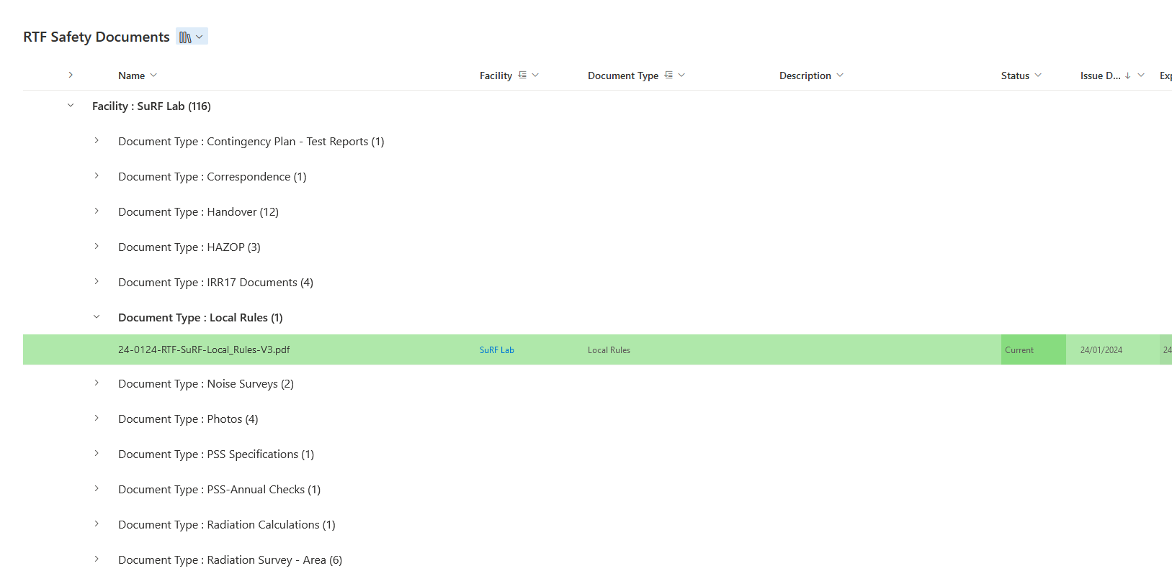

#### Example 2: All RTF documents

This view displays all documentation from the same library as example 1, including archived and superseded files. There are different columns on display in this view, though it is grouped in the same way:

