



**2nd iSAS website meeting**

6th December 2024

Enclosed:

* Overleaf template website “skeleton”, colour-coded for each WP

* Contents 1st drafts for each WP

Notes:

**Contents writing guidelines**

Extract from Overleaf skeleton detailing what is expected from WP Leaders:

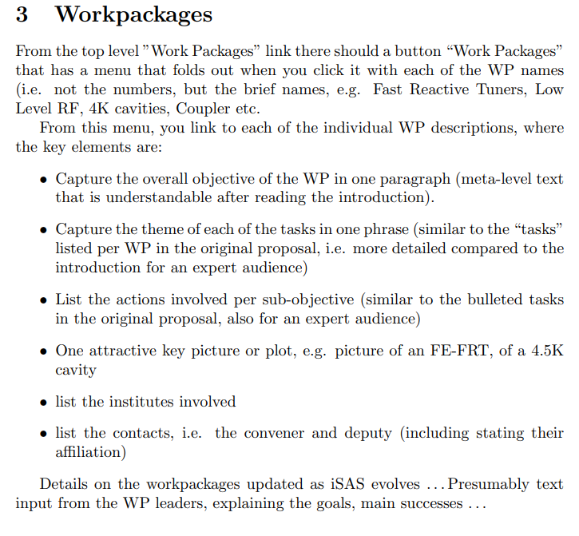

**Questions**

All WP content in 1 page or “clickable” content de unfold details?

* Tasks in 1 sentence could be clicked on to access the full sections

Can we use the 3D drawing from WP6 as a portal to click on specific technologies that link to related WPs?

* Yes, but probably a simpler one, slightly edited to adjust to iSAS WP in introduction section of the website to illustrate the parametric design objective (and keep this one drawing in WP6 section)

Contacts: should we indicate e-mail addresses?

* Uniform across all WP, possibility to send e-mails without publishing the e-mail addresses explicitly (task for the web development)

**Proposal**

Contents writing phase

* To write 1st drafts for the sections as organised by the skeleton work group, maybe in doubt taking WP2 draft as an example

Then editing phase

* To check specific wordings, ask for advice on nice illustrations, etc., in January

Achievements can be added in a year

* To get to a fuller advancement before showcasing achievements made (achievement here refer to publications, technologies developed rather than milestones or deliverables)

**Next steps**

* WP drafts to be updated according to exchanges and sent to Adèle Cc Achille and Jorgen by Dec 13 for the web developer to integrate contributions into the website

* Review to be expected for early January