***2.8.2 SRF Materials for 4-K operation***

***Very short/simple introduction to what 4-K operation is all about***

Accelerating cavities are the heart of a particle accelerator, devices capable to accelerate charged particles up to tens of MV/m. State the art, bulk niobium superconducting radio frequency cavities, guarantees dissipations few watts of power, more than a million times less than normal conducting cavities. However, working temperature of this cavities is 2 K, where the cryoplant’s Carnot efficiency decreases dramatically to less than 1%, requiring a grid power of many megawatts.

Substituting Nb with a thin film of Nb3Sn, the highest critical temperature of this superconductor would allow to move the cavities working temperature up to 4.2-4.5 K, reducing the electrical power requirements of the cryogenic plant by a factor 3, as well as its complexity.

Different aspects of the Nb3Sn thin film cavities must be optimized to increase the technology maturity, and ISAS will address in particular tunability and flux trapping, two fundamental properties for cryomodule operation.

The ambition of iSAS is to make a further step towards the implementation of thin-film cavities in high-performance cryomodules operating at temperatures greater than 4.2 K, and accordingly to save energy from the cryogenic system.

**WP3 - Nb3Sn-on-Cu films for 4.2-K cavity operation**

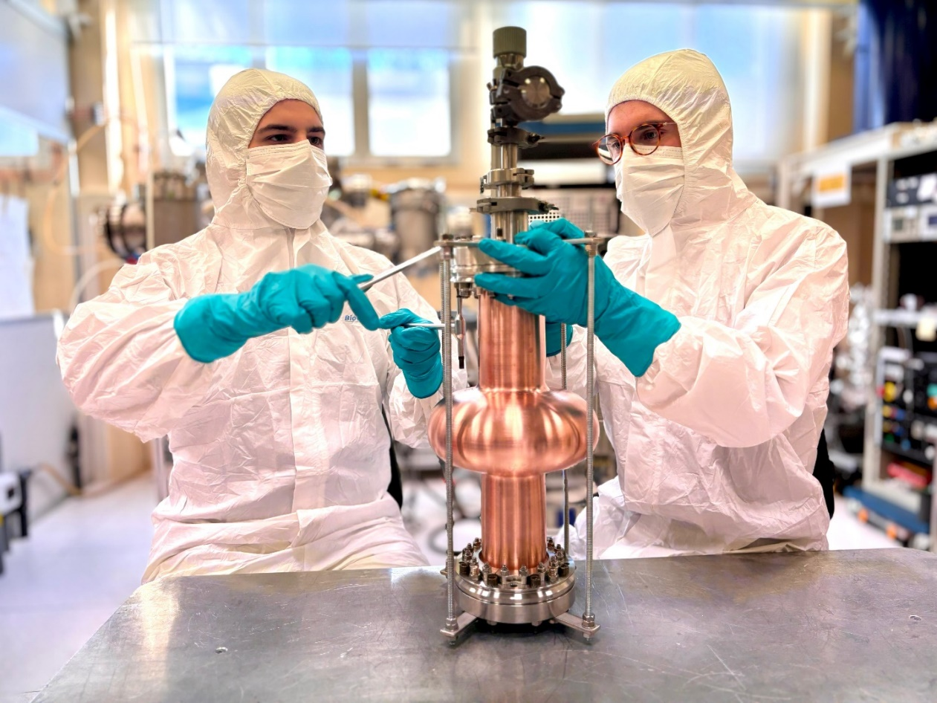

**Main Goals**

***(It might initially show only the sentence in bold. Then clicking on it would open the text of the entire paragraph). In blue link to I.FAST WP9, In red reference to TA#1 and INT#1***

**The objective of iSAS WP3 is focused on the development of thin-film cavities and aims to transform conventional superconducting radio-frequency technology based on off-shelf bulk niobium operating at 2 K, into a technology operating at 4.2 K using a highly functionalized material, where individual functions are addressed by different layers**. A high-performance accelerating cavity requires several properties, and the layeredstructure allows them to be individually optimized: high Tc (SC in stoichiometric composition), low Rs (highmorphological quality of the SC coating), high thermal conductivity of the substrate to the cooling medium (use ofCu substrate), low flux trapping (reduction of pinning centers, study of cooling protocols), high mechanical strengthand durability of the coating (enhancement by adaptive layers).

Complementary to H2020 project [I.FAST](https://ifast-project.eu/wp9-innovative-superconducting-thin-film-coated-cavities) and in synergy with TA#1 and INT#1, iSAS WP3 is focused on minimizing trapped fluxand increasing coating mechanical strength to allow cavity tunability. Minimizing trapped flux, or at leastcharacterizing its dynamics, is critical for cavity installation in the cryomodule. Flux trapping directly affects thequality factor and thus the power dissipation. It is crucial to characterize it to determine how best to minimize it. TheiSAS methodology is to modify the coating recipe, the cooling protocol, or act on the cryomodule shielding in synergywith INT#1. A cryomodule requires constant tuning of the cavities, both to maximize performances but also to reduce power consumption. Nb3Sn, and in general all A15 superconductors, are brittle intermetallic materials. The challenge is to avoid performance degradation of the film as it is subjected to the mechanical stresses imposed during normal operation

**ISAS WP3 OBJECTIVES** ***(can be moved to impact section)***

* Explore new coating parameters for planar samples and small resonators to minimize flux trapping and enhance the mechanical strength in in SC Nb3Sn films
* Characterize trapped flux, flux viscosity and the interaction with the RF field in small resonators and samples
* Devise cavity tuning schemes for Nb3Sn cavities. The implementation of FE-FRT (WP1) to assist will be considered.
* Develop adaptative layers by atomic layer deposition on Cu that are stable up to 650 °C.
* Improve state of the art 1.3-GHz superconducting coating recipe based on Tasks 3.2-3.4 results
* Coat and perform full cavity characterization @4.2 K (Q vs E, Q vs F, and flux trapping in vertical test stand.

**Tasks**

***Task 3.1 Coordination*** *- This task aims to coordinate the different task activities and organize the periodic WP meetings.*

**Task 3.2: Flux trapping** – This task aims to minimize flux trapping in Nb3Sn thin films studying and optimizing coating parameters and cooling procedure.

**Tak 3.3 RF Tunability** - This task aims to study and improve mechanical properties of SC thin films to assess the impact of future cavity tuning during normal 4.2 K operation.

**Task 3.4: Adaptive Layers** - This task aims at developing suitable adaptative layers synthesized by Atomic Layer Deposition (ALD) to reduce the detrimental effect of mechanical deformation on the superconducting properties of Nb3Sn.

**Task 3.5: Working Cavity @ 4.2 K** – This task encompasses the main outcome of WP3: to optimize the SC cavity coating procedure at 1.3 GHz using the experience and knowledge gained in Tasks 3.2-3.4. and demonstrate suitability for operation at 4.2 K.

**Impact**

***(It might initially show only the individual sentences in bold. Then clicking on it would open the text of the entire paragraph)***

**The move from 2-K to 4.2-K SRF cavity operation is expected to have huge impact on the sustainability of future and even existing SRF-based particle accelerators on all scales,** from the few 10-MeV to the multi-GeV range. The cryogenics and RF systems are typically the two largest energy consumers in SRF facilities. The development of 4.2- K cavity technology would have an even greater impact than the recently developed niobium doping, which reduces the grid power for cryogenics by about 35%. In contrast, increasing the operating temperature to about 4.2 K using Nb3Sn technology, while maintaining the cavity quality factor, automatically reduces the grid power for cooling by about 66%. Furthermore, unlike with doped niobium, the complexity of the cryogenic facility is significantly reduced by avoiding sub-atmospheric operation, reducing both infrastructure invest and maintenance costs.

**The direct benefit lies in the dramatically reduced grid power for cooling.** GeV-class SRF facilities save of order several MW and for very large facilities, such as future particle and nuclear physics accelerators and Higgs Factory colliders based on SRF LINACs, this number can be several 10 MW and more. Pulsed SRF-based facilities limited by cryogenic power would also be able to increase their duty factor, thereby increasing their brightness or luminosity to reduce the needed operating times for a given scientific output.

**The development of 4.2-K superconductors will be key for industrial SRF-accelerator applications**, due to the reduction in size and complexity of the cryoplant. Leveraging the iSAS achievements, the goal is to use 4.5-K SRF technology to enable cryoplant-free operation of small accelerators. iSAS will explore a number of technical challenges to make a step towards this goal. “Compact” SRF accelerators for a variety of applications spanning nuclear physics and safety, bioscience, materials science, medical applications, lithography, water treatment, ultra-fast electron microscopy and similar would benefit from these developments.

Finally, thin-film technology with A15 superconductors such as Nb3Sn also enables SRF technology applications that are impossible with bulk Nb, in particular when very high magnetic fields need to be applied, which quench Nb. **Applications for dark matter exploration**, particularly for axion research, are one such example where the possibility of coated copper cavities for improving the sensitivity of haloscopes is already being explored.

**Institutes involved**

INFN, CEA, HZB, UKRI

**Contacts**

Cristian Pira, INFN LNL, WP3 Leader, 3.1 Task Leader, cristian.pira@lnl.infn.it

Oleg Malishev, UKRI, WP3 Deputy Leader, 3.2 Task Leader, oleg.malyshev@stfc.ac.uk

Oliver Kugeler, HZB, 3.3 Task Leader, oliver.kugeler@helmholtz-berlin.de

Thomas Proslier, CEA, 3.4 Task Leader, thomas.proslier@cea.fr

Reza Valizadeh, UKRI, 3.5 Task Leader, reza.valizadeh@stfc.ac.uk