WP2: Low-Level RF Controls

# Main Goals

**Overall objective:**

The power used to generate the accelerating field constitutes a significant share of the overall accelerator power consumption. Efforts to minimize and optimize the generation of the accelerating field translate directly in energy savings. The low-level (i.e, low-power) radio frequency systems aim to measure and control the field inside the cavity to accelerate the beam. The iSAS (Innovate for Sustainable Accelerating Systems) project aims to reduce the energy consumption of superconducting radio-frequency (SRF) accelerators through several innovative approaches in low-level radio frequency (LLRF) control systems:

**Optimized Cavity Bandwidth**

The choice of the cavity's external quality factor has a major impact on the required operation power and a strong influence on the challenges linked to resonance control. Efficiency, performance, and reliability must be considered to find the optimal cavity parameters.

**Optimized Resonance Control**

Optimizing resonance control algorithms that rely on legacy piezo-based systems and developing novel vibration analysis and compensation techniques based on modern control theory.

**Ferro-Electric Fast Reactive Tuners (FE-FRTs)**

Investigating the use of Ferro-Electric Fast Reactive Tuners (FE-FRTs) to control transient beam loading and detuning caused by microphonics.

**RF Power Source Optimization**

Optimizing the efficiency of RF power sources by reducing the power overhead through intelligent RF amplifier steering.

**Machine-learning-Based Controls and Diagnostics**

Investigating the use of machine-learning-based feedback controllers for efficient RF field control, in particular in the case of high loaded-quality factor cavities (i.e., narrow bandwidth) or to support fault detection and fast recovery.

These technologies aim to minimize RF power sources and wall plug power requirements for SRF accelerators without compromising the quality of the accelerating field nor the functionality of the RF controls.

# Impact

**Optimizing the Cavity Bandwidth**

For continuous wave RF, an operating cavity with high external coupling reduces the power requirement for a given operating accelerating voltage, making this mode of operation attractive from an efficiency point of view (AC wall plug power to RF power ratio). The downside of narrow bandwidth cavities is their increased sensitivity to microphonics, as well as longer time constants, making the system slower to react to changes in beam loading or feedback regulation. A tradeoff must be met, taking into consideration multiple aspects such as field stability, robustness of operation, RF overhead, and efficiency.

It is also to be investigated how the external coupling can be changed and how the design of external quality factor tuners (waveguide, so-called stub tuners) can be adapted to existing designs.

**Optimizing Resonance Control**

Without resonance control, detuning induced by microphonics or beam transients can be compensated for using additional power. Resonance control techniques can minimize the need for additional power, hence providing a more efficient accelerator system. These techniques can rely on model-based detuning estimation, possibly using external noise sensors to correlate with environmental disturbances. Algorithms, including active noise compensation to mitigate microphonics or combined resonance and field controls, are promising approaches to optimizing resonance control.

**Use of FE-FRT for beam loading compensation**

The energy absorbed by the beam when passing through an accelerating cavity, referred to as beam loading, is typically compensated for by injecting more power into the cavity during the beam time. A ferroelectric fast ferrite tuner offers an alternative to effectively change the cavity impedance seen by the beam when it passes through to minimize beam loading. If proven successful, this approach could potentially provide a more efficient beam acceleration by reducing the amount of RF required for beam loading compensation

**RF Power Source Optimization**

The solid-state technology for power amplifiers has evolved over the years; new designs based on Gallium Nitride (GaN) offer higher efficiency than the legacy DMOS transistors and hence constitute an attractive option for power source optimization. Working towards more compact power RF sources should also be investigated to minimize their footprint in accelerator tunnels. Finally, an active control of the drain voltage would allow the amplifier to stay in its saturation regime and optimize its efficiency. Such designs are being looked into to optimize the parameters of the power source as a function of its operating point, in an attempt to improve the overall system efficiency. These optimization approaches are specific to the accelerator's design and mode of operation.

In the case of pulsed klystrons, shaping the modulator pulse was successfully implemented to optimize the use of available RF power to minimize the energy consumption (see achievement section)

**Machine-learning-Based Controls and Diagnostics**

Machine learning techniques can be used to stream the continuous flow of data, detect and automatically categorize anomalies. This approach can support experts in their work, ensuring high machine-up time and early fault detection. Such algorithms also provide new insights into the operation and are a prerequisite for reacting proactively to system faults. Furthermore, machine learning algorithms can prove quite powerful in optimizing control parameters, with potential resonance and field control applications.

# Achievements

Example of energy savings at the European X-ray Free Electron Laser (XFEL) achieved by reducing the RF overhead. The non-linearities in the high-power chain introduced by the tight shaping of the modulator pulse were compensated with new algorithms developed in the LLRF system. [Branlard et al. Linac 2024 “RF-based energy savings at the FLASH and European XFEL linacs”]

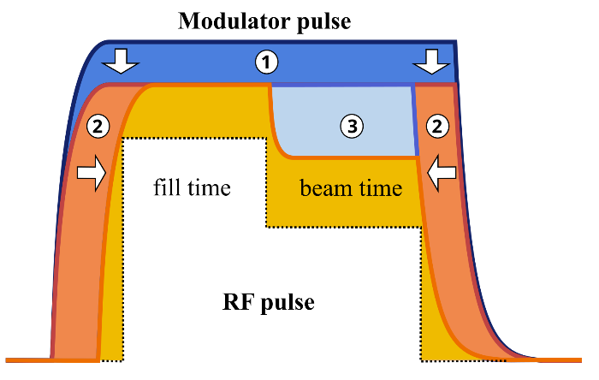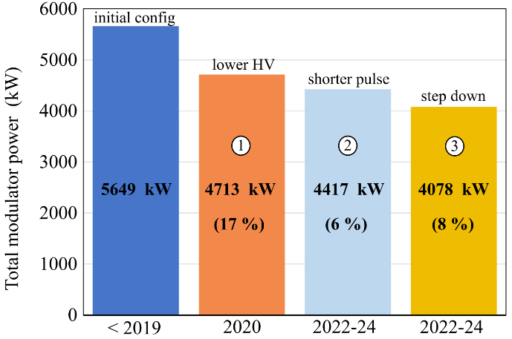

The modulator pulse is shaped to reduce the RF overheard by (1) lowering the high voltage, (2) reducing the pulse length and making use of the rising and falling edges, and (3) introducing a step-down during beam time when less power is required.

# Institutes

* DESY: Deutsches Elektronen-Synchrotron
* HZB: Helmholtz Zentrum Berlin
* CNRS: Centre National de la Recheche Scientifique

# Contacts

* Convener: Holger Schlarb (DESY)
* Deputy: Julien Branlard (DESY)
* Contact at HZB: Axel Neumann
* Contact at CNRS: Christophe Joly