**WP6: Integration (Results) into Accelerator and Collider Research Infrastructures**

**Main goal**

In addition to the parametric design for a new LINAC cryomodule that integrates all the new iSAS technologies, the objective of iSAS is also to expedite the incorporation of the energy-saving technologies in existing accelerator systems and to validate some of these integrations. The engineering challenges to adapt an existing LINAC cryomodule originally designed for the ESS will be identified and engineering solutions will be developed to integrate all iSAS technologies, starting with the improved power couplers and HOM dampers. The objective is to thoroughly test the performance of this modified, fully equipped LINAC cryomodule at the ESS test facilities. Leveraging on iSAS, the potential of the LINAC cryomodule to reach energy savings through energy recovery of high-power beams will be validated at the upcoming PERLE research accelerator facility at IJCLab. The ambition is also to study whether the integration can be simplified by combining the FE-FRT and HOM couplers into a single device, which would allow retrofitting these iSAS technologies into machines like the HL-LHC to address transient detuning.

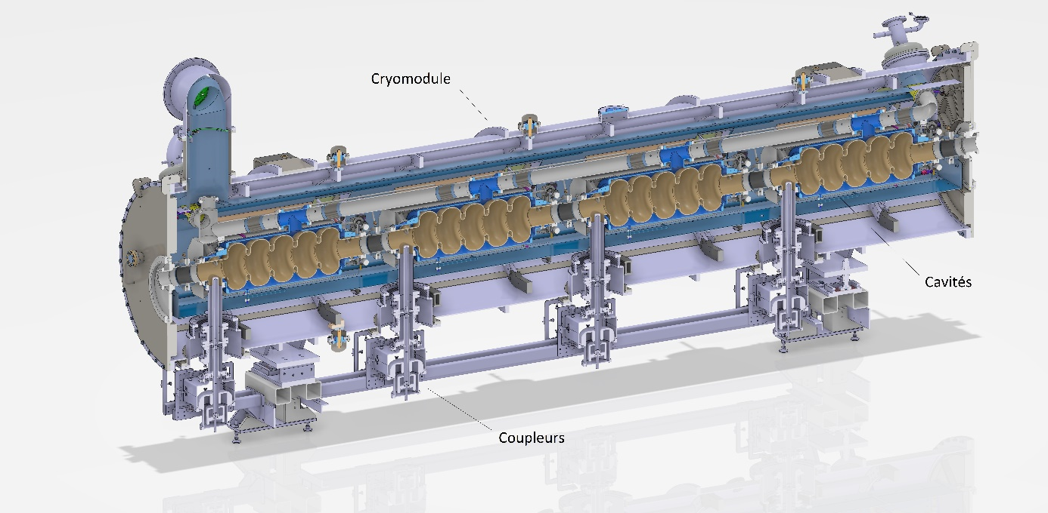

**WP organization**

Five institutes are involved in the WP6:

* Centre National de la Recherche Scientifique (CNRS, France)
* Commissariat à l'Energie Atomique et aux énergies alternatives (CEA, France)
* European Spallation Source (ESS)
* Istituto Nazionale di Fisica Nucleare (INFN, Italy)
* University of Lancaster (UL, UK)

WP6 partners (main contacts):

CNRS: Guillaume Olry (WP Leader)

CEA: Arnaud Madur (Deputy)

ESS: Nuno Elias

INFN: Dario Giove

UL: Graeme Burt

Task 6.1 (lead by CNRS): Coordination

Task 6.2 (lead by UL): Retrofitting Fast Reactive Tuners (FE-FRT) into existing cryomodules HL-LHC oriented

Study of a single device combining a FE-FRT and a HOM coupler in a same port.

Task 6.3 (lead by CNRS): Adapt the existing ESS cryomodule

Study of the modifications of the existing ESS cryomodule based on feedback from assembly experience at CEA and testing experience at ESS.

Task 6.4 (lead by INFN): Fabrication and validation of cryomodule components

Fabrication and test of the critical components (SRF cavity, tuning systems, HOM couplers, ...)

Task 6.5 (lead by CEA): Assembly and test of adapted cryomodule

Assembly of the adapted cryomodule and cryogenic and RF test.

**Achievements**

**Task 6.2:**

* **Need G.Burt inputs.**

**Task 6.3:**

* **Design of a new cavity string: well advanced (80% complete).**
* 5-cell cavity made of bulk Niobium
* A helium jacket made of Titanium (including the beam pipes)
* 4 HOM couplers and the fundamental power coupler to the end-groups
* A tuning system based on the one developed for the ESS Spoke cavities
* A Beam Line Absorber between cavities. A PhD thesis may start in spring 2025.
* A dual-layer magnetic shield.

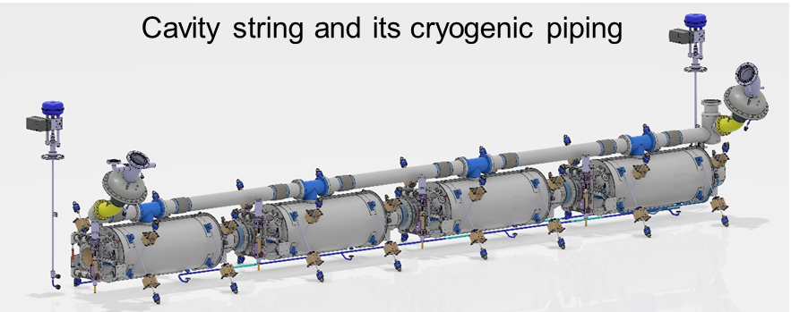

* **Integration of the Power Couplers (from WP4): well advanced (80% complete).**

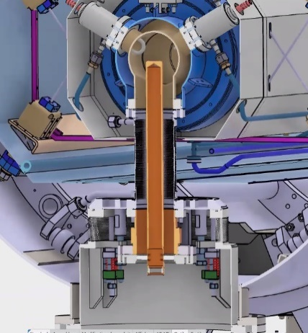

**Task 6.4:**

* **Niobium purchase (done).**

Order of the Niobium material needed to the fabrication of 4 cavities: done.

* **HOM couplers design (90% complete)**

