Résumé - Summary

Minutes : Buncher Design Review

Validation du document – Document validation
Rédigé par  Written by | Date | Signature
Frederic BOULY (LPSC/CNRS) | 30/01/2025 | 
Vérifié par  Reviewed by | Date | Signature
R. Roux

Approuvé par  Validated by | Date | Signature
D. Reynet

Liste de diffusion – Distribution list
Interne – Internal | Externe - External
 | Perle collaboration

Table des matières - Table of contents

1 conditions and participants 3
2 Highlights 3
3 Main Actions 7

conditions and participants
Date : 30/01/2025
Place : IJClab Orsay, room
Participants : Patricia Duchesne (PD), Christophe Joly (CJ), Walid Kaabi (WK), Samuel Marchal (SM), Julien Michaud (JM), Connor Monaghan (CM),Juan-Luis Munoz (JLM), Guillaume Olry (GO), Denis Reynet (DR), Raphael Roux (RR), Frederic Bouly (FB).

indico link : https://indico.ijclab.in2p3.fr/event/11552/
Presentations are available on the indico website.

Highlights

- Project status (WK) / Injector WP status (RR)
Reminder on theproject status and work package structure is made.
It was remind that a short term goal is to provide a TDR by the end of this year (ie 2025).

The question of how to better include ESS Bilbao in the collaboration is raised. It was expressed that on ESS Bilbao side the situation is not very clear on the project status the situation and the will of IJClab.
Everydody agrees on the fact that the situation must be clarified through MoU or a Collab. Agreement. This predesign review will help to define the technical work and that need to be done by JLM.
The main message is that ESS Bilbao is more than welcome in the project collaboration as well as its technical expertise. PERLE Directory will clarify soon the situation with ESS Bilbao management to continue the collaboration and the work on the Buncher. ESS Bilbao involvement in the project will correspond to JLM at ~10% of his time until the Buncher is tested and installed on the injector line. Work would be : RF design cavity and coupler, help for multiphysics calculation, support/expertise for call for tender, fabrication and RF tests follow-up.

- Beam dynamics (CM)
It was reminded that beam dynamics is dominated by space charge effect at the beginning of the injector.
Multi-objective algorithm was used to explore the best tuning according to input beam distribution from the gun.
Opal was used for beam simulations. Some results were compared with ASTRA code. From the literature/experience/documentations it seems that ASTRA SC model is less accurate/developed than in OPAL (3D meshing).
CM and RR agreed on the used of the field map. Nevertheless this a 1D field and it is not the last field map version from JLM.
The ‘final design’ 3D filed map must be included in the bean dynamics model. 3D field map has asymmetries. One should check that beam dynamics is not affected.
The determined field amplitude (maximum Ez value on beam axis ), is ~1 MV/m, corresponding to a value of accelerating voltage V0T> 100 kV/m.
It corresponds to an RF power (power loss ) of ~1.6 kW.
These values should be considered as minimal values: we should be able to increase the field until ~2.4 kW power loss.

- RF deign (JLM)
JLM presents ESS Bilbao and main project of construction of a neutron production facility.
Then the RF design process is reviewed. it was reminded that 2 desgn solutions were initially studied : Cerl and Nose cone.
The nose cone was adopted and everybody agrees that the final parameters are at ~1.6 kW :
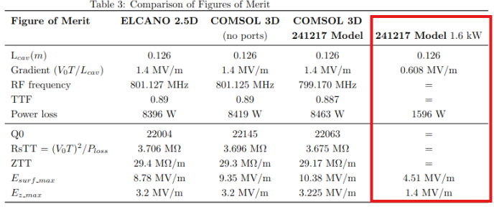

Everybody agrees that the Electromagnetic design of the cavity is freezed.
On should now focus on the coupling (and potential tuner) port.
The cavity length was briefly discussed. The Lcav =0.126 m value was set due to the available space between solenoids.
One important aspect is also discussed: the frequency sensitivity to radius change is of : 5MHz/mm.

- Mechanical design (SM)
3 types of mechanical design have been explored and are reviewed.
Calculation at 5 kW and 1.6 kW power loss are summarised below from SM presentation.
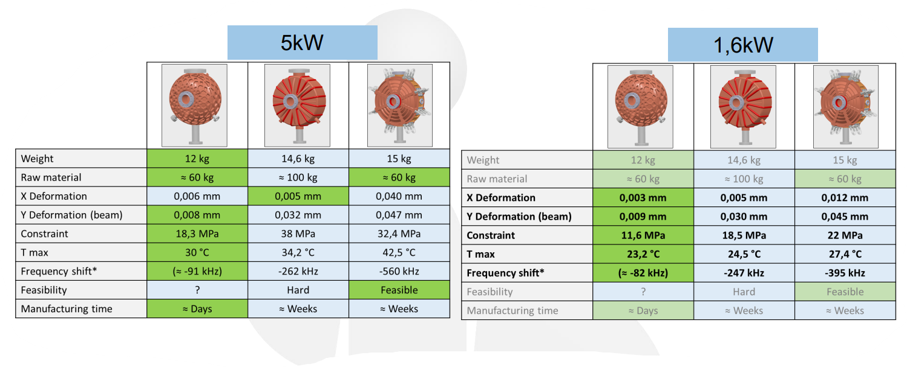
Solution 1 is 3D printing and is not considered as a solution for fabrication of the PERLE buncher. It is considered that there are too many uncertainties to go for this fabrication process: detuning after fabrication and brazing, how to recover frequency (by plastic deformation), as well surface state and rugosity.

Solution 3 is the favoured solution. Deformation due to pressure (water cooling and air -> vacuum) and cooling efficiency ay 2 kW should be checked with advanced calculation before validating the design solution.
Cavity material will be copper.

GO also ask why not using Elliptica cavtiy design with a copper buncher?.
it is agreed that there is not enough space, beam tube are too large, the fringe field will make the buncher less efficient (not so high Q0). No necessity to go to elliptical shape (i.e.; multipacting risk is low).

Cost estimation is also discussed: for ‘classic’ fabrication such as solution 3 it should be around 50 keuros.
Finally, egarding future fabrication responsibilities, it was discussed and agreed that IJClab will take in charge the call for tender. Choice for manufacturer will be made with support and advise from ESS Bilbao as well as the manufacturing monitoring.

- RF power and coupling (CJ)
The required in coupling from power coupler should be equal to the Q0.
1”5/8 semi-rigid coax. cables are planned to be used between amplifier and power coupler.
Regarding RF amplifier : Solid state will be used. Manufacturer (targeted one : Jema) will produce module of 2.4 kW (price : 50 keuros with cabinet). Development of the RF system will take ~12 months, because the manufacturer will have to develop the full cabinet to includes all modules for High Power (i.e 40 kW), even if one or two modules will be installed for the buncher.
Call for tender to be prepared as soon as possible. RR and CJ must agree of the required mode of operation : Pulsed & CW, duty cycle range?
CJ precise that having an amplifier which can operate with a ‘variable’ duty cycle will not affect the price (good news!)
The LLRF system will be the same than the LLRF of the booster Superconducting cavity.
Budget estimation of the full system is also discussed.
Cavity + amplifier + coupler (15 ke) + LLRF + ancillaires (cables, etc ) : ~150 keuros.

According the required power the solution for magnetic coupling is adopted.It enable to adjut the coupling according the fabricated cavity Q0 value.For this solution one should think about the cooling if necessary.

- Coupler and frequency Tuning (JLM)
JLM present the buncher developed at ESS Bilbao for the ESS injector.
A first adaptation to the PERLE buncher from ESS design (352 MHZ) is shown and discussed.
First simulations with this conceptual design tend to show that the temperature increase on the antenna is manageable without coupling (70° with 1.8 kW).
This remains a conceptual design and matching section to 800 MHz should be adapted as well as ports compatibility should be checked in details. But in principle this design can be adapted.
RR proposed to first evaluate and check if there are a solution from industry with more simple feedthrough (“of the shelf”) and the possibility to add a magnetic antenna. Otherwise the proposed solution from JLM should be adopted.
Then the frequency tuning is discussed. The cavity RF design should be done at lower frequency to anticipate frequency increase due to fabrication and brazing.
During fabrication the frequency tuning will done by pulling on the beam pipe , along the beam axis.

Precision from RR after the meeting (email 31/01/2025):
About one copper bunching cavity at 3 GHz; after brazing there was a frequency shift of -700 kHz.
Applying a mechanical deformation along the axis of the cut-off tube allowed us to recuperate + 500 kHz.

Conisdering the RF power, a movable tuner is considered as not necessary. A spare port for a fix tuner can be envisaged. This has to be determined with further RF studies.
Finally it was agreed that the cavitu detuning can be controlled with the water temperature. The temperature control accuracy with the chiller must be below +/- 0.1 °, since the resonance frequency sensitivity is ~50 kHz/°. New simulations must confirm this value

Main Actions
Action | Resp. | Date | Comments
Set-up collaboration agreement or MoU | PERLE project directory & ESS Bilbao management | Feb. 2025
Provide buncher 3D RF field maps | JLM -> CM | Feb 2025
Include 3D buncher field maps in beam dynamics model | CM | Feb 2025 | Check if asymmetries may affect beam dyna.
Estimate thermal power dissipated at maximum power 2.4 kW | JLM and SM | March 2025
Evaluate frequency shift as function of constraints | SM and JLM | March 2025
Evaluate feasibility and construction cost for solution 2 and 3 with final decision | SM, DR, RR, JLM | April 2025
Prepare call for tender for RF amplifier | CJ, RR | March 2025
Check for commercial solutions of RF feedthrough for coupler | RR | Fev 2025
If previous solution not possible, Continue RF adaptation and design of power coupler | JLM | April 2025
Evaluate the need of fixed plunger for final tuning | JLM, RR | April 2025

it is different from common cell length definition L = βλ/2 = 0.805*0.375 /2= 0.151 m.
Also discussed the possibility to carry out prototyping, in parallel of PERLE project development is to be kept in mind. There are potential manufacturers for copper 3D printing in Europe (Spain).

