(ISAS website)

WP5: Integration into the design of a sustainable LINAC cryomodule

Main Goal
The objective of iSAS WP5 is to address the common engineering challenges associated with a coherent integration of the iSAS technologies into a LINAC cryomodule. Leveraging the developments in the ESS cryomodules, a new parametric design of a LINAC cryomodule will be developed to address the engineering challenges of integrating each of the new technologies.

In addition, the aim is to develop for the first time a fully integrated parametric design that incorporates the entire portfolio of iSAS energy-saving technologies to achieve the largest possible energy savings for new accelerating systems. To maximise the impact, the parametric design of the LINAC cryomodule will embrace concrete guidelines as a toolbox for engineers to expedite the integration of iSAS technologies in the widest variety of current and future accelerator-driven facilities and realize energy savings without delay.

To unlock the full energy-saving capability of this LINAC cryomodule in energy recovery mode, the objective of iSAS is to also address the challenging beam dynamics requirements when operating the new cryomodule in new ERL-based accelerators with recirculating beams. This entails a major step beyond the state of the art and would for the first time truly integrate the most relevant energy-saving technologies into the designs of ERL-based accelerators.

WP organization
Four Institutions are involved in the iSAS WP5
- EUROPEAN SPALLATION SOURCE ERIC (ESS, Sweden)
- ORGANIZATION EUROPEENE POUR LA RECHERCHE NUCLEAIRE (CERN, Switzerland)
- CENTRE NATIONAL DE LA RECHERCHE SCIENTIFIQUE (CNRS, France)
- ECOLE POLITECHNIQUE FEDERALE DE LAUSANE (EPFL, SWITZERLAND)

WP5 Main contacts:
- ESS: Nuno Elias (WP Leader) (ESS, Sweden)
- CERN: Vittorio Parma (Deputy WP leader)
- CNRS: Guillaume Olry
- EPFL: Mike Seidel

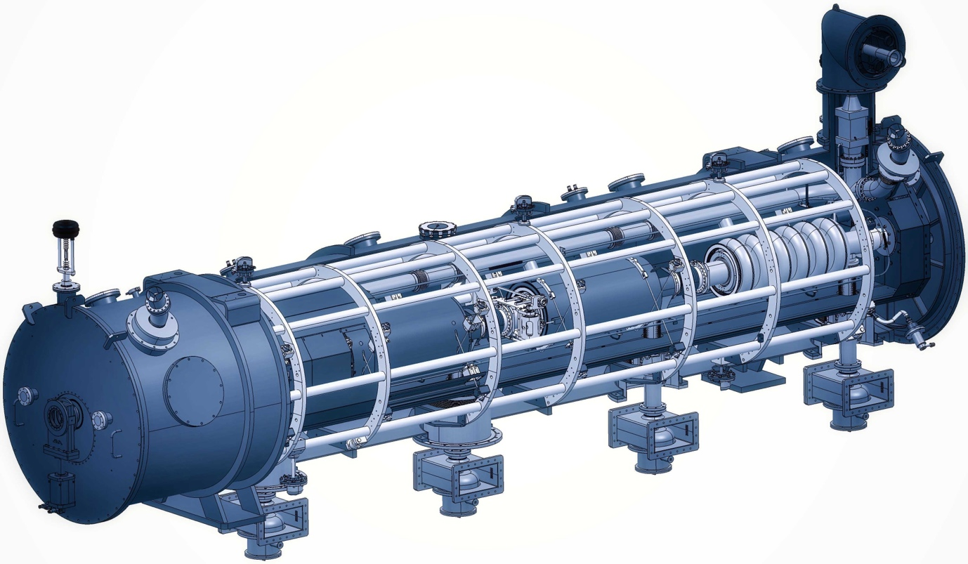
Figure 1: Artist view of the ESS cryomodule serving as a base to explore the integration of iSAS energy saving technologies and the parametric design of a new cryomodule.

Impact
Cryomodule designs developed for specific projects are frequently modified for use in later projects. For example, the TESLA cryomodule was initially developed for e+e--colliders (e.g., the ILC), but has been adopted for the EuXFEL and the LCLS II FEL light sources. The new technologies developed by iSAS constitute a major step forward for accelerators using superconducting cavities, for both large RIs as well as industrial-type accelerators. But it is not sufficient to only validate the technologies themselves, it must also be demonstrated that the technologies can be integrated into a cryomodule and perform as designed in a real accelerator environment. This is where the WP5 parametric design of a sustainable cryomodule, combined with the results from WP6, will make an impact.

Once the sustainable LINAC cryomodule has been fully vetted, it can serve as a model for energy-efficient technology to be adapted for a variety of SRF accelerator applications, both for large RIs and compact accelerators. Operation at 4.2 K will make superconducting RF technology available in universities and small research facilities that are not able to finance and operate a 2-K cryogenic plant, which requires dedicated staff just to maintain the plant. Future integration in the iSAS cryomodule of new, high-capacity cryocoolers coming on the market will enable many new small SRF accelerators such as Compton back-scattered sources and FELs, with high efficiency and exceptional performance. This will unlock new research opportunities in biology, chemistry, material science and many other fields, some of which are now only niche research topics due to the lack of available facilities.

The viability of proposals for future RIs with high-power electron beams depends on the availability of a fully developed cryomodule that can be used in energy recovery mode. Clearly, large collider projects such as the FCC and others must rely on tested and matured technologies. The developments in WP5 set the stage for a future validation of the iSAS cryomodule, including its energy-saving iSAS technologies, in a multi-pass ERL testbed such as PERLE. This in time will enable the European particle physics community to address the advantages of colliders with high-power electron or positron beams, knowing that the technology is ready for deployment.

In addition, the beam-dynamics studies will help optimize the cryomodule for high-current ERL mode, with a view to attain best possible energy-recovery efficiency. The beam intensity and recovery efficiency are limited by particle losses and the onset of beam instabilities driven by the beam’s interaction with various components in the module.
Countermeasures developed in the iSAS project, related to HOM damping, cavity alignment tolerance specification and possibly beam orbit feedback will be considered. Thus, the module will be fully optimized for all aspects of energy efficiency: RF, cryogenics and beam energy recovery to maximize beam intensity per unit of grid power.

The beam dynamics solutions are designed to maximize the beam current in ERL-based accelerators. Achieving these high intensities has a major impact on the science performance of the RI, either by enabling maximum luminosities in a collider application or by enabling the brightest X-ray beams in an FEL facility. The beam dynamics study will also address the problem of particle losses at levels that are unacceptable for radiation protection. The deceleration of a spent beam and optimal energy recovery in the SRF cavities is associated with anti-damping and the generation of beam tails, causing such unwanted losses. The study aims at reducing these losses, allowing to decelerate the beam to very low energies. The recovery of the largest fraction of the beam energy will have the impact to achieve maximal energy efficiency and to minimize the environmental burden of radioactive materials generated in the beam dump.
The energy of the particles in the decelerated beam will be below neutron activation thresholds, strongly reducing the radiotoxicity of the materials in the beam dump. The delivered simulation codes related to the beam dynamics with ERL-based accelerators using the newly designed sustainable LINAC cryomodule will benefit the accelerator community in tackling similar problems.

Achievements

The main achievements of WP5 are linked with the iSAS project deliverables are milestones:

ESS cryomodules experience and benchmarking with other recent facilities
  - Compilation of the lesson learned from the ESS CM testing activities, technical commissioning, and initial operation.
  - Benchmarking with projects in the implementation phase (worldwide).
  - Develop a roadmap to develop a new, sustainable CM design

WP5 organises a technical review of the ESS CM design, tests and commissioning experiences. Operational results are described, analysed and correlated with the project design choices.
As part of this activity a benchmarking with other CM designs is performed. And sets the roadmap for integrating the initial progress with the technology developments obtained in WP1 to 4 into a new, optimized energy-efficient CM design.

Sustainability criteria for LINAC cryomodule design
  - Integrate findings from the other iSAS WPs into a generic CM design.
  - Explore the sustainability criteria for the design.

Based on the developed technical roadmap and under the guidance of a pan-European forum of experts, the developments of the parametric design are conducted. Direct or indirect, the relevant European institutes are engaged and a continued dialogue with WP1-4 experts
enhance the transversal integration activity. In addition to the technical, energy-efficiency and performance criteria in the roadmap, also cost-efficiency criteria is considered. The integration of heat exchangers, thermal shields, cryogenic line, vacuum and monitoring instruments is be addressed.

Beam Dynamics for ERL-based accelerators with energy-efficient cryomodules
  - Simulate the beam dynamics of ERL-based accelerators when the energy efficient CM is included.
  - Study the lattice design to optimize the beam and energy saving performances

The beam dynamics study includes collaborations with leading research groups across Europe. ERL-specific beam dynamics effects using dedicated simulations study the impact of the new sustainable SRF system on the beam quality, the attainable intensity and the efficiency of energy recovery in a quantitative way. The study identifies the most relevant beam dynamics effects in ERL mode including the new iSAS technologies and realistic lattice parameter sets are developed for specific research applications of ERL-based accelerators that will allow to specify the tolerances and acceptable HOM amplitudes. These results help in the development of efficiency-optimized ERL-based accelerators. The results also set limits on the required HOM damping for the cryomodule that are designed in this work package and feed back into the HOM design criteria in WP4.

