

iSAS weekly meeting
4th March 2026

Present: Achille Stocchi, Adèle de Valera

Notes:

AMD
* Adèle sends new detailed budget to Alena, who asked for it (after meeting w/ Julie to get up to speed on AMD updates)
* Achille signs (visa) the AMD - DR4 to initiate the process (Juliette Guérin if Alena doesn't respond) - Alena did it and it's been signed by Annabelle Alves (legal entity through DR4)
* AMD signed doesn't mean it validated & now it automatically predicts 45 days processing until April 10
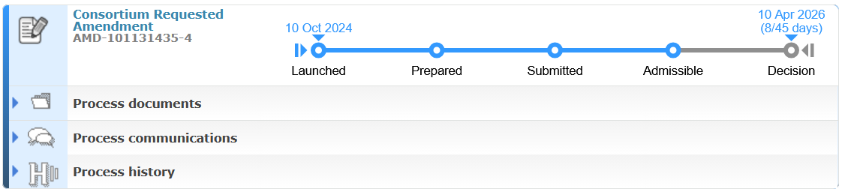
* EPM contract needs AMD #2 for RP2 - Ketel & PO meeting March 6 to discuss justification for it

CA
Internal validation asked for, due Friday Feb 6 - then review the following week - then signature process to be opened
* Julie EPM Hadron2030? Not iSAS IPE anymore? Alena in the meantime? Alena & only Alena from DR4 to keep in all messages
* Adèle has sent the final version to be signed to consortium partners Cc Alena
* 1 signature for now: HZB
* UKRI - Peter new responsible & UKRI to be named beneficiary?

RF2.0 & iSAS
Feb 10 meeting feedback to get
Julie to be absent from June for at least 3 months when application would take place
* Adèle asks for Barcelona presentations
* Barcelona meeting: WPs have started to take shape
* 4 years, not 3 years
* KIT proposes to be Coordinator (will have difficulties to be at TIARA meeting, to check)

M&D due Feb 2026
All WPs concerned got reminder
* Decision to be made by Achille about WP5 D#16 scission in 2 distinct reports: ESS lessons learned & benchmarking of other facilities (delayed a few weeks because of delayed data gathering from the other facilities)
* Adèle asks if Jorgen available for some validations
* Coordination panel proposal for validations?
* To circle back to all WP Leaders or Task leaders about their own M/D validated & accounted for
* Consequences of late AMD - M & D not existing YET to be reported & pending bc not delayed YET

Coordination panel meeting
March 10
* To be prepared

Justification @IJCLab
Maïlys helped to clarify what info Adèle couldn't access in Agate-Tempo
Clément Ascenção gave Adèle larger "reading" access in Agate-Tempo to follow better
* Agate-Tempo: did the 3 IJCLab complete their timesheets? Did Achille validate them? Did Marina validate after that?
* Adèle asked @Virginie /UF01074
* Adèle sends personalised message to 3 concerned by Agate-Tempo in iSAS from Maïlys's message Cc Achille

Justification RP1 @DR4
* Adèle responds @Justine Monnet via DR04.Justification.Europe <dr04-justification.europe@cnrs.fr> - good for now ("très complet')

RP1 report
60 days max
* Adèle asks for a template for the report (not in SyGMa a priori)

Review meeting
Date confirmed June 1st 9:00-12:30 CET
* Adèle creates an Indico page for the Review meeting w/ detailed agenda to link in invitations
* Adèle to check if online meeting, get expert contact to invite & sends invitations for everyone including WP Leaders & Deputies (warning that if convener absent, Deputy should confirm their ability to replace the convener)
* External expert nomination objections? Tbd by Consortium

Berlin meeting
"Registrations open" save the date sent

Communication
* Zanon has asked validation on their social media posts on Zanon partnership w/ iSAS - Achille ok - funded by the EU mention to add

