The SAMPIC Project

The SAMPIC project aims at building a new multi-channel acquisition system for particle detectors with timing performance in the ps range. This system is based on the use of ultrafast, high dynamic range analogue memory chips which have already proven their capabilities for 15 ps timing measurements. The design and the operation of these ultrafast analogue memories is one of the fields of expertise of a joint LAL/Irfu team which has applied for 3 patents since 2000 on this subject and designed several chips used in industry and in experiments. To push the time resolution limits under 10 ps, the new “SAMPIC” chip will use a finer pitch micro-electronics technology that provides higher speed, bandwidth and also an increased integration level. The later permits gathering more channels in the same chip, integrating new functions but also implementing the multiple buffering strategies required to minimize the acquisition dead time of the final system. The first prototype of the SAMPIC chip will be sent to fabrication in July 2012. Its main goals are to evaluate the performance of the chosen AMS CMOS 0.18 µm technology and to test the main building blocks – some of them are totally new or are using innovative architectures - required for the final chip. This first prototype integrates 16 complete channels each including a 64-cell depth, a 10 GSPS analogue memory, a discriminator, an ADC and a counter. It should permit already targeting the same fine time measurements as aimed in the final SAMPIC, but with some dead time. In parallel, the board carrying the chip is being studied and will be manufactured in September.
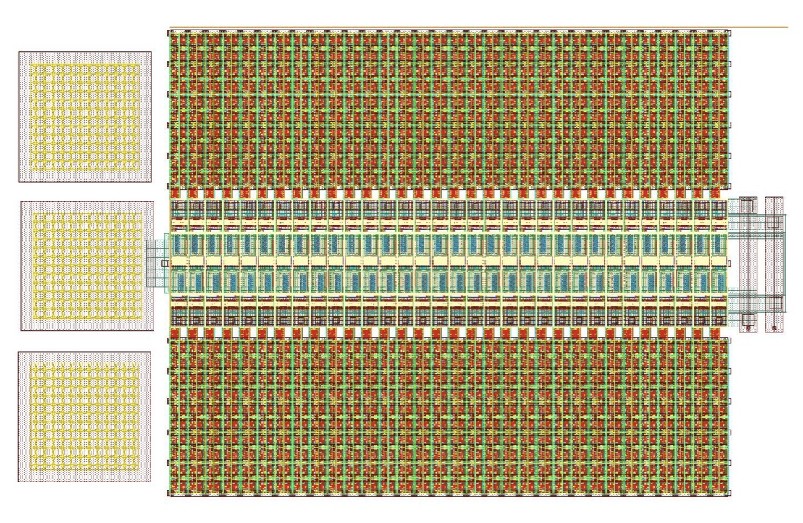
Layout of a SAMPIC channel (270µm x 600 µm)

