P2IO short presentation
Guy Wormser, P2IO coordinator

P2IO is one of the 100 local excellency clusters (« Laboratoires d’Excellence » or LABEX ) created in March 2011, in the framework of the “Grand Emprunt” at the initiative of French government to boost local partnerships to promote research and innovation. Details of the Labex initiative can be found here (in French )
http://investissement-avenir.gouvernement.fr/content/action-projets/les-programmes/centres-dexcellence
The complete file P2IO submitted in response to this tender is available here :

http://p2io.extra.cea.fr/Phocea/file.php?file=Ast/1/Labex_P2IO.pdf&reload=1322474577
The P2IO brochure describing P2IO in a few pages is available here:
http://www.labex-p2io.fr/Phocea/Vie_des_labos/News/index.php?id_news=22

In this document, we present P2IO contour, its main objectives and first actions.

- P2IO contour
P2IO is in essence a network of 9 laboratories and 3 teams all located in Orsay-Saclay-Palaiseau region, focused on the search of the basic laws of nature regarding the infinitely small, the infinitely large and the conditions for life emergence. This corresponds to a workforce of around 2000 persons, representing between ~30% to 90% of the French research effort in these fields, depending on the specific domains.
P2IO has decided to select from its even larger scientific and technologic portfolio the following priorities:
  - 4 scientific priorities (P1 to P4)
    - P1 :symmetries in the subatomic world,
    - P2: dark components of the Universe,
    - P3 : strongly coupled nuclear matter,
    - P4 : formation of stellar systems and conditions for the emergence of life
  - 3 technologic priorities (R1 to R3)
    - R1 : innovations in accelerator science and their related spinoffs,
    - R2 : advanced sensors and spinoffs,
    - R3 : data mining and simulation
  - 2 transversal priorities
    - Energy : nuclear energy for the future;
    - Health : health, new methods in imagery and therapies

We will ask P2IO scientific Council to revisit these priorities and to consider adding one.

The repartition of the staff as a function of laboratories, scientific thematic and priorities is given the table below:

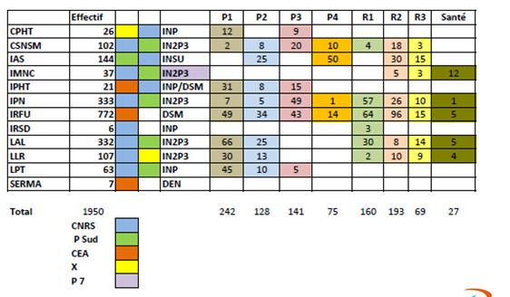

- P2IO main objectives
P2IO research project is based on three pillars : Explore, Transform, Structure.
- Explore will be performed through strong support for innovative interdisciplinary initiatives and new collaborations in the most promising topics in P2IO scientific objectives
- Transform will be performed through a new vision of the collaboration between P2IO members. Joining forces between P2IO labs to create common technological platforms will foster new world-class facilities, boosting P2IO research to unprecedented levels. The P2IO Labex, in prefiguration of the P2IO pole of the new Plateau de Saclay campus, will favour the emergence of one of the five largest subatomic centers in the world with one of the highest degree of excellence and recognition.
- Structure will stem from the integrated governance and its role as a contact point for internal and external collaborations.
Some important success criteria have already identified:
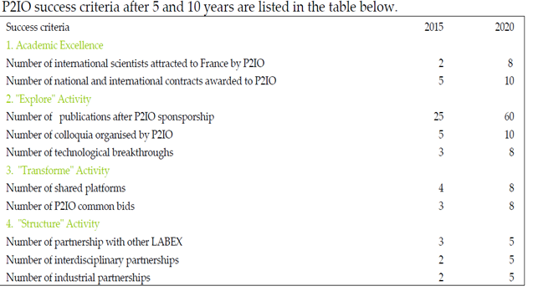

The scientific Council will be asked to comment of these indicators.

- P2IO first actions
P2IO has already launched a significant number of actions representing in total more than 2.5 M€.
3.1/ 2 calls for post-doctoral positions:
- one in 2011 for 5 positions starting in September 2011 . 41 applications received. The recipients list is given below and a report for all these programs is available on the Indico site.
http://indico2.lal.in2p3.fr/indico/materialDisplay.py?materialId=2&confId=1812
- F. Deliot (IRFU) Recherche du quark top (P1)
- – M. Arnaud (IRFU) Exploitation des clusters cosmologiques de Planck(P2)
- – G. Grosdider (LAL) Calcul QCD sur réseau (P1,R3)
- – C. Munoz (IPN) DVCS et extraction des GPD (P3)
- – F. Poulet (IAS) Evolution climatique de mars et recherche des conditions d’habitabilité (P4)

- One in 2012 for 8 positions (3 theorists and 5 experimenters).The recipients list is given below (11 applications received for theory and 31 for experimenters)
- G. Moreau (LPT) - Bosons de Higgs au-delà du modèle standard
- - M. Petropoulos (CPHT) - Trou noir : aspects microscopiques et holographiques
- - S. Wallon (LPT) - Théorie et phénoménologie des réactions exclusives dures en QCD
- E. Armengaud (IFRU, P2) : Recherche de WIMP's à l'aide des détecteurs EDELWEISS-III
- - T. Ljungvall (CSNSM, P3) : Electromagnetic moments in exotic nuclei
- - G. Martinet (IPNO, R1) : Matériaux supraconducteurs : une alternative au niobium massif pour les cavités
- - R. Poeschl (LAL, P1) : Pattern recognition and machine learning for imaging calorimeters
- - S. Della-Negra (IPNO, P4) : Météorites, exobiologie et le projet Andromède

3.2/ Two calls for R&D programs
- One in 2011, targeting small upstream programs (between 50 and 100 k€), for a total budget of 593 k€
- Accélérateurs
- - G. Martinet (IPN) Couches Mince Supraconductrices
- - D. Lunney (CSNSM) Décélérateur anti-protons
- - P. Bambade (LAL) Détection halo ATF2
- • Capteurs
- - D. Yvon (IRFU) TEP nouvelle génération
- - E. Delagnes (IRFU) électronique 1 ps
- - V. Tatischeff (CSNSM) Téléscopes Compton nouvelle génération
- - S. Marnieros (CSNSM) Bolomètres nouvelle génération
- - D. Bernard (IN2P3) Polarimétrie rayons gamma
- • Données
- - D. Chamont (LLR) Calcul en grille avec processeurs GPUs
A status report for all of tehse projects is available on the indico page
http://indico2.lal.in2p3.fr/indico/materialDisplay.py?materialId=3&confId=1812
- One in 2012, targeting larger programs and infrastructures (budget 500 k€)
  - Captinnov (minimum of 181 k€)
  - Virtual data (250 k€)
(see the projects presentation (in French) on the SC indico page
http://indico2.lal.in2p3.fr/indico/conferenceDisplay.py?confId=1812)
Such an alternance between these two styles of R&D projects is meant to continue during P2IO’s lifetime.
Besides these major calls, P2IO has launched some other important actions :
- Training (see the report on the Indico web page)
- Outreach including the preparation of a major event : “The night of the two Infinities” which will take place on October 9th , a brochure (in French and in English), a web site, a bi-monthly newsletter
- Support to 8 existing platforms (90 k€ per year)
  - Halls de tests cavités
  - Banc BETSI
  - PHIL
  - DALTON
  - Station d'essais
  - CALVA
  - JANNUS
  - GRIF
The SC will be invited to comment on these actions and on their relevance with respect to P2IO objectives.

