USEFUL INFORMATION FOR THE MEETING
Just in case you have any problem my mobile number is 699322221.
TID offices
Now TID offices are in the Telefónica District (Distrito Telefónica or DC). It is located in:
Distrito Telefónica
Ronda de la Comunicación, s/n
28050 Madrid
ESPAÑA

To go from the airport to the Distrito Telefónica, you can take the underground (take the 8 line in the Aeropuerto T4 or Aeropuerto T1 T2 T3 stop and in the Nuevos ministerios stop you can take the 10 line to Ronda de la Comunication). http://www.metromadrid.es/en/viaja_en_metro/trayecto_recomendado/resultado.html?rbOrigen=estacion&idOrigen=808&calle=+Introduce+street+name...&numeroOrigen=n%BA&cmbCiudadOrigen=Madrid&lugar=+Introduce+location...&rbDestino=estacion&idDestino=1054&calle2=+Introduce+destination+street+name...&numeroDestino=n%BA&cmbCiudadDestino=Madrid&lugar2=+Introduce+location...&Simple=0&buscar=Search
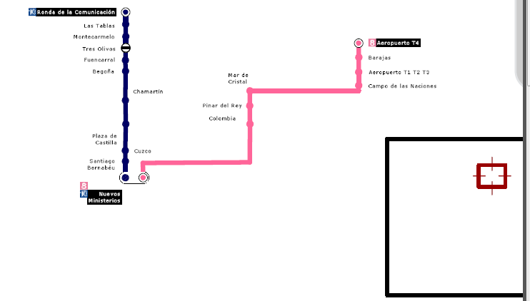
There is an underground stop in the center of the Distrito Telefónica: RONDA DE LA COMUNICACIÓN.

Meeting Rooms
The room booked for the StratusLab meeting are in the building Norte 1 and Norte 2. The underground station is close to the Norte 1 and Norte 2 buildings. Just leave the underground and turn on the right.
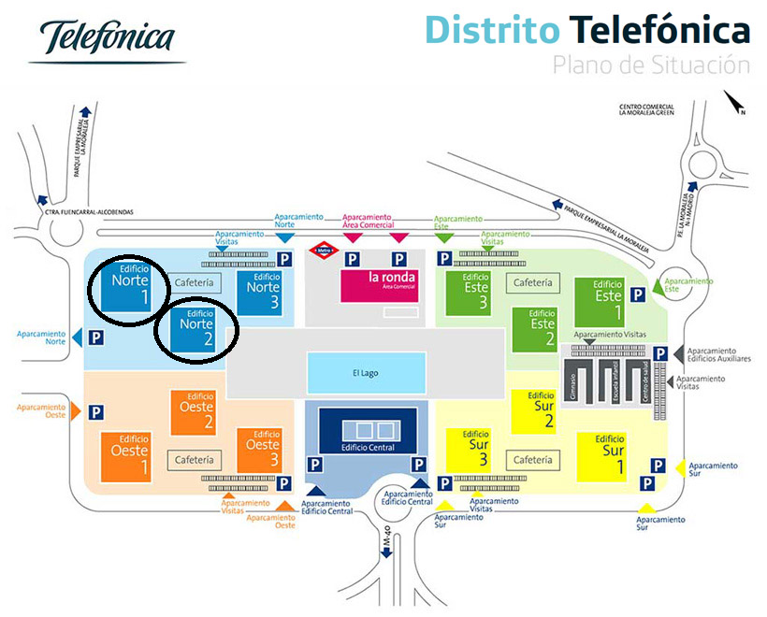
The meeting on Monday is in the Norte 1 building. When you enter in the building shows your passport or identity card to the security guard. They will give you a visit card which allows you to enter in the Norte 1 and 2 building for the two meeting days.

Concretely, the rehearsal meeting is hold in:
- 25/05/2012: Room DCN01 S08P C52. Building Norte 1, floor 8, room C52
- 26/06/2012: Room DCN02 S04P D51. Building Norte (North) 2, floor 4 room D51
The rooms are booked from 10 – 17. Thus, you can go directly from the airport to TID.
Wifi
I have asked for you some WIFI visit accounts. I will provide to you the data on Monday.

Social Event
I have booked in the restaurant Villa Godio por having dinner on Monday:
Web: http://restaurantevillagodio.com/
Address: Calle de San Agustín, 6, 28014 Madrid
Underground stop: Anton Martin line 1
http://www.metromadrid.es/en/viaja_en_metro/trayecto_recomendado/resultado.html?cmbDestino=-221.81399536132812|2424.888671875|Calle%2Bde%2BSan%2BAgust%C3%ADn%2B6%2B%28Madrid%29&btnBuscar.x=49&btnBuscar.y=4&idOrigen=2&idDestino=0&rbOrigen=estacion&rbDestino=calle&cmbEstacionOrigen=2&cmbEstacionDestino=&cmbTipoDia=1&cmbHora=09&cmbMinutos=01&rbTipoRuta=rapida&Simple=1&numeroOrigen=&numeroDestino=6&busqueda=true
