Instructions for preparation of abstracts for RPHDM2024.
Please restrict the title to two lines

A. Alpha^{1 *}, B. C. Beta² and G. Gamma^{1,2}

¹Affiliation with laboratory and/or university name, city, country
²Affiliation with laboratory and/or university name, city, country

This is a sample abstract for RPHDM2024.
1. Abstracts should be written in English. The abstract should fit on one A4 page (210 mm × 297 mm) and should come without a page number. It should be submitted in PDF format through the conference website.
2. Please respect the format instructions below and do not modify the pre-defined margins.
3. Use 11 pt Roman font for the text or a similar font such as Times New Roman throughout the abstract.
4. The title should be typed in 14 pt boldface font and centred.
5. Leave a single (9 pt) empty line after the title line(s), after the author(s) list and after the affiliation(s) list.
6. Only one figure file is allowed. It will be shown in color in the electronic version of the abstract. If you submit a color figure it is your responsibility to ensure that it is easy to read and understand even in grayscale mode. When including the figure, pay close attention that your final PDF file does not exceed 5 MB size limit.
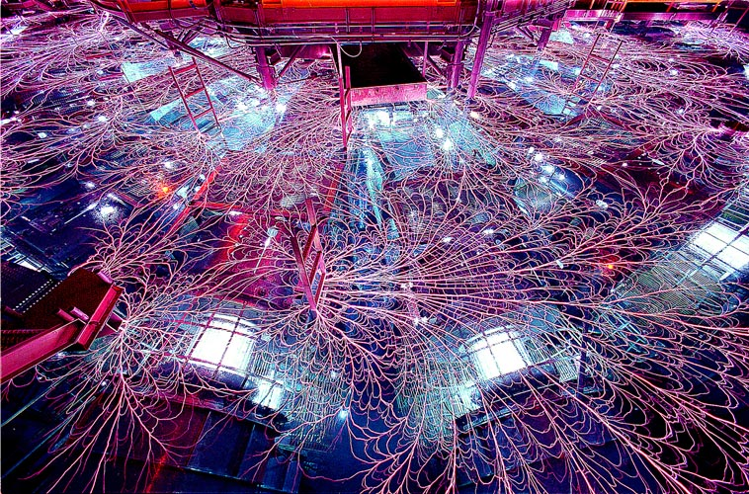
Figure 1. The Z machine (Sandia National Laboratories, Albuquerque, NM, USA).
7. References in the text should be given by numbers in square brackets [1,2]. The list of references (11 pt) follows the last line of the text. Follow the style of Ref. [1,2] below.

References
[1] C. F. Hooper, Phys. Rev. 149, 77-91 (1966).
[2] R. A. Alpher, H. Bethe and G. Gamow, Phys. Rev. 73, 803-804 (1948).

* E-mail: corresponding.author1@abcdef.fr

